CS152 Section 3

### Q1. Cache Organization

Consider a 1 KiB 4-way set-associative cache with 32-byte cache lines. The address is 12 bits wide. How are the address bits partitioned?

* Tag:
* Index:
* Offset

### Q2. Replacement Policies

Suppose we see the following stream of accesses where A, B, C, D, and E represent unique addresses from different lines that all map to the same set:

A, B, C, D, B, A, E

Assume the cache has four ways and all lines in the set are initially invalid. When address E is accessed, one of the cache lines must be evicted. For each replacement policy, which line gets evicted?

* FIFO

| Way0 | Way1 | Way2 | Way3 | Policy State after request |
| --- | --- | --- | --- | --- |
|  |  |  |  |  |
|  |  |  |  |  |
|  |  |  |  |  |
|  |  |  |  |  |
|  |  |  |  |  |
|  |  |  |  |  |
|  |  |  |  |  |

* NMRU

| Way0 | Way1 | Way2 | Way3 | Policy State after request |
| --- | --- | --- | --- | --- |
|  |  |  |  |  |
|  |  |  |  |  |
|  |  |  |  |  |
|  |  |  |  |  |
|  |  |  |  |  |
|  |  |  |  |  |
|  |  |  |  |  |

* LRU

| Way0 | Way1 | Way2 | Way3 | Policy State after request |
| --- | --- | --- | --- | --- |
|  |  |  |  |  |
|  |  |  |  |  |
|  |  |  |  |  |
|  |  |  |  |  |
|  |  |  |  |  |
|  |  |  |  |  |
|  |  |  |  |  |

* PLRU

| Way0 | Way1 | Way2 | Way3 | Policy State |
| --- | --- | --- | --- | --- |
|  |  |  |  |  |
|  |  |  |  |  |
|  |  |  |  |  |
|  |  |  |  |  |
|  |  |  |  |  |
|  |  |  |  |  |
|  |  |  |  |  |

### 

### 

### Q3. Pseudo-LRU Replacement

PLRU works by maintaining a binary tree for every cache set, with the leaves representing ways (not stored) and the interior nodes holding directions (each stored as 1 bit). For each cache access, trace the path from the root to the leaf node. At each interior node, set the direction to be the opposite of the path you followed.

Complete the table. Assume cache lines are 32 bytes, there are 8 sets, and the tree starts with all bits set to 0. For simplicity, we consider accesses to sets 0 and 1 only.

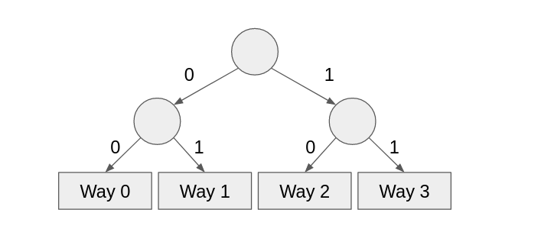

|  | **Cache Tags (hex)** | | | | | | | | | |  |
| --- | --- | --- | --- | --- | --- | --- | --- | --- | --- | --- | --- |
| **Address (hex)** | **Set 0** | | | | | **Set 1** | | | | | **Hit?** |
| **Way 0** | **Way 1** | **Way 2** | **Way 3** | **PLRU State** | **Way 0** | **Way 1** | **Way 2** | **Way 3** | **PLRU State** |
| 208 | 2 | inv | inv | inv | 110 | inv | inv | inv | inv | 000 | no |
| 22C |  |  |  |  |  | 2 |  |  |  | 110 | no |
| 41C |  |  | 4 |  | 011 |  |  |  |  |  | no |
| 604 |  |  |  |  |  |  |  |  |  |  |  |
| 320 |  |  |  |  |  |  |  |  |  |  |  |
| 214 |  |  |  |  |  |  |  |  |  |  |  |
| 310 |  |  |  |  |  |  |  |  |  |  |  |
| 50C |  |  |  |  |  |  |  |  |  |  |  |
| 404 |  |  |  |  |  |  |  |  |  |  |  |

### Q4. Cache Optimizations

For each technique, indicate whether implementing it will **increase**, **decrease**, or have **no change** on each aspect.

| Technique | Hit Time | Miss Penalty | Miss Rate | Hardware Complexity |
| --- | --- | --- | --- | --- |
| Smaller, simpler caches |  |  |  |  |
| Multi-level caches |  |  |  |  |
| Smart replacement policy |  |  |  |  |
| Pipelined writes |  |  |  |  |
| Write buffer |  |  |  |  |
| Sub-blocks (sector cache) |  |  |  |  |
| Code optimization |  |  |  |  |
| Compiler prefetching |  |  |  |  |
| Hardware prefetching (stream buffer) |  |  |  |  |
| Victim cache |  |  |  |  |